



**Color Palette 82F5A8**

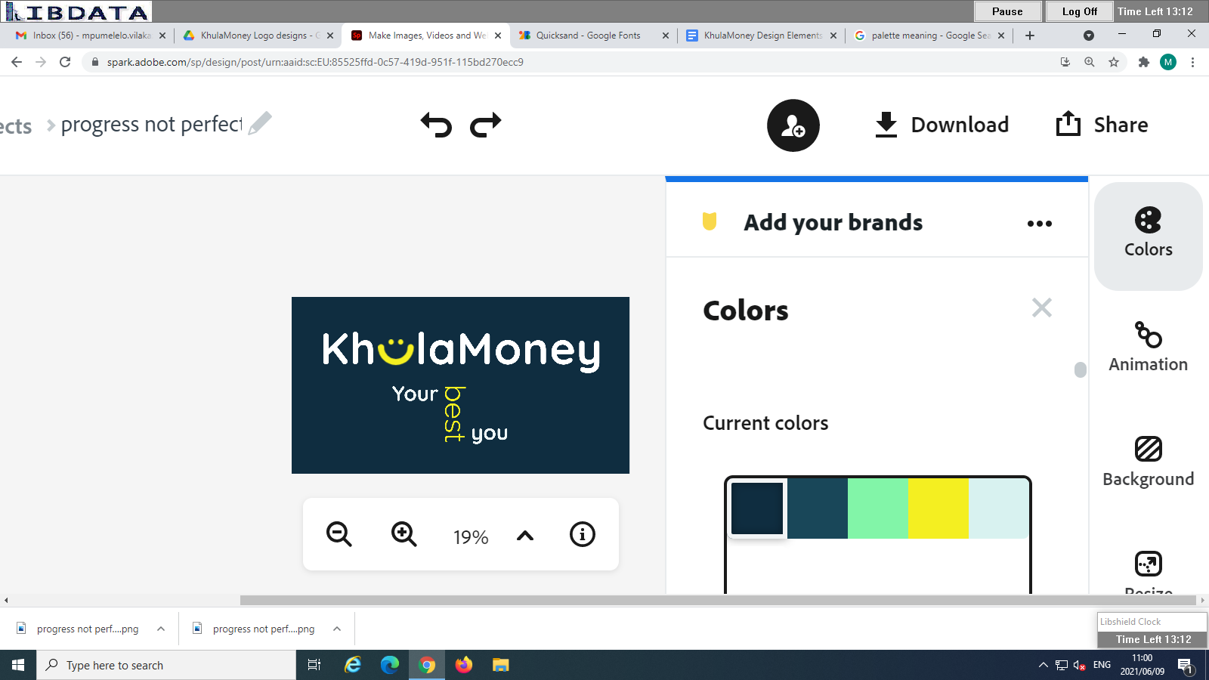

**Individual Colors**



** -** Color code: #0F2D40 (Navy) - Color Code: 82F5A8 (Lime)



-Color code: 194759 (light Navy)

* Color code: F4EF21 (Yellow)
* FFFFFF (White)

|  |
| --- |
|  |

* Color code: D8F2F0 (Pale Blue) 
* Color Code: #207178

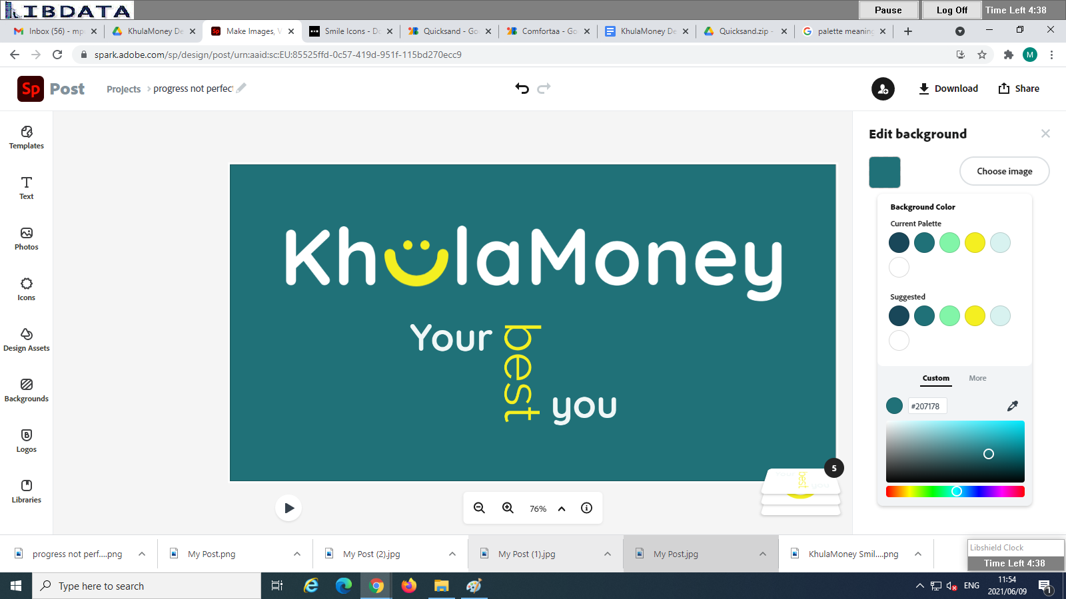

Fonts:

Logo fonts:

Quicksand

<https://drive.google.com/file/d/1l3o36z920HW8R27zsd_6HlS32Gz87_Hn/view?usp=sharing>

Font family ZIP link

Comfortaa ( documents and communications)

<https://drive.google.com/file/d/1e-I0wAU6wHokAweGeI3gGjZb-sP3pCo6/view?usp=sharing>

Font family ZIP link

KhulaMoney Design Elements Folder:

<https://drive.google.com/drive/folders/1aO7zVIBoMXbL7aMQxlOUhsLNNoKS0U5b?usp=sharing>